Ch-5 Efficiency (Consumer surplus, Producer surplus)

Welfare and Efficiency

Welfare Economics

* Welfare Economics is the branch of Economics −→ Allocation

of Resources and Well-being

”How does resources allocation affect the well-being?”

* On the whole, examines what is best for the society
* People are economic agents and rational beings (Assumption)
* They would maximise their benefits; driven by self-interests
* We will cover the basics of Welfare Economics

Market Economy

* In the market economy, there are buyers and sellers
* The market is efficient at the equilibrium.

Market failure when it is not at the equilibrium (e.g. shortage and surplus)

* Consumer Surplus
* Producer Surplus
* Total Surplus
* Concept of Tax and Effects of Tax

Some basic geometry formulae

1. 1 Area of Triangle: 1/2 X Height X Base
2. 2 Area of Rectangle: Length X Width

Graphs

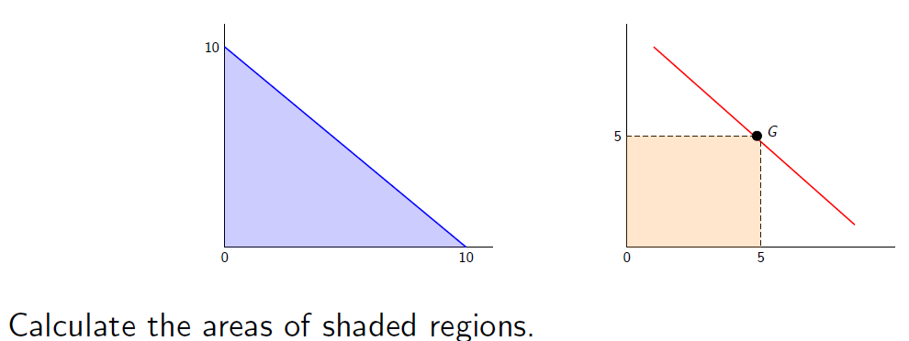

Consumer Surplus

* Consumer surplus is the amount a buyer is willing to pay minus the amount it pays −→ measures the benefits of consumers/buyers
* Consumer surplus is measured using the demand curve

Willingness to Pay

* In the market economy, there are buyers and sellers
* Buyers represent the demand side
* Demand for a product or service means that you want that good and you are willing to pay for it
* How much you are willing to pay for it can be observed from the demand function and/or demand curve

Consumer Surplus (CS) = Willingness to Pay (WTP) - Amount Paid

You would not spend more than 20tk for a soft beverage. You went to the store and saw the price was 15tk. How much would be the consumer surplus?

Graphical Representation

1. 1 Using demand curve to measure the Consumer Surplus (CS)
2. 2 The area under the demand curve and above the paid price depicts your CS

Graphs

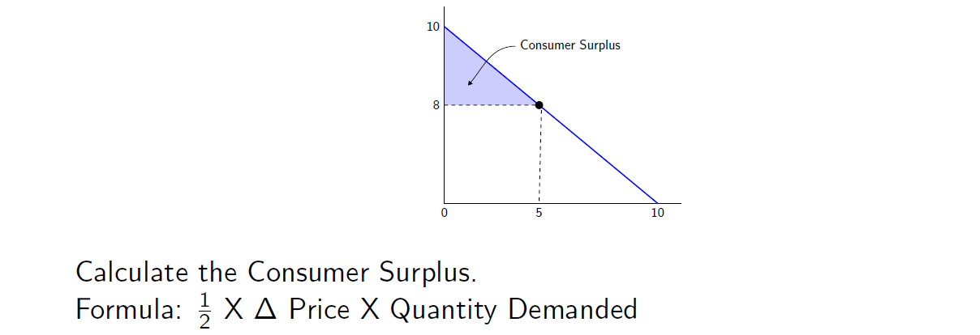

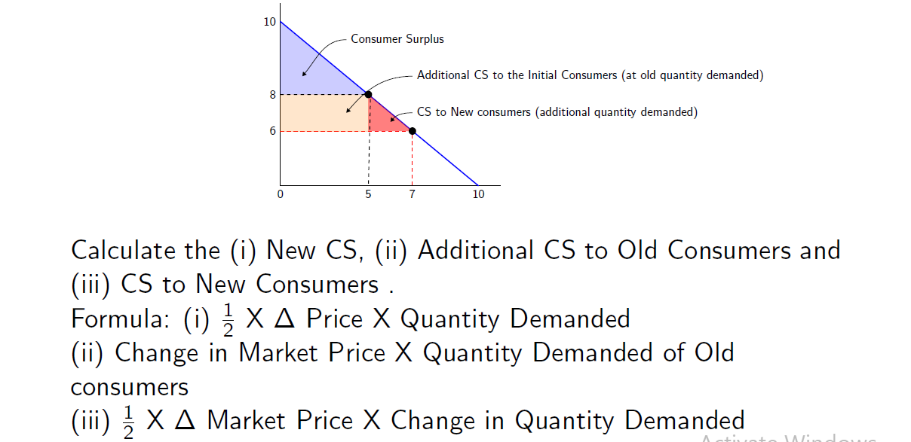

Producer Surplus

* Producer surplus is the difference of the amount a seller recieved from selling the good and the cost of producing the good −→ measures the benefits of suppliers/sellers
* Producer surplus is measured using the supply curve
* Producer Surplus shows the benefits received by the sellers/suppliers/producers

Willingness to Sell

1. Willingness to sell (WTS): Minimum amount the seller would be willing to receive
2. WTS measures the cost associated with producing the good or service

Producer Surplus (PS) = Amount Received - Cost (or WTS)

You would not sell a soft beverage less than 12tk. You sold a bottle at 15tk. How much would be the producer surplus?

Graphical Representation

1. Using supply curve to measure the Producer Surplus (PS)
2. The area under the received price and above the minimum price that you are willing to sell at depicts your PS

Graphs

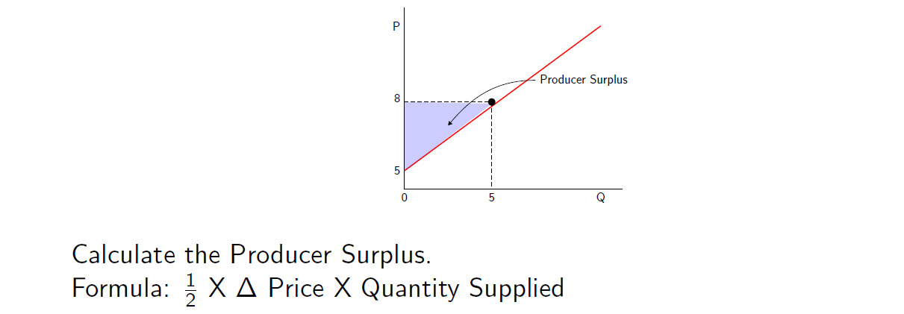

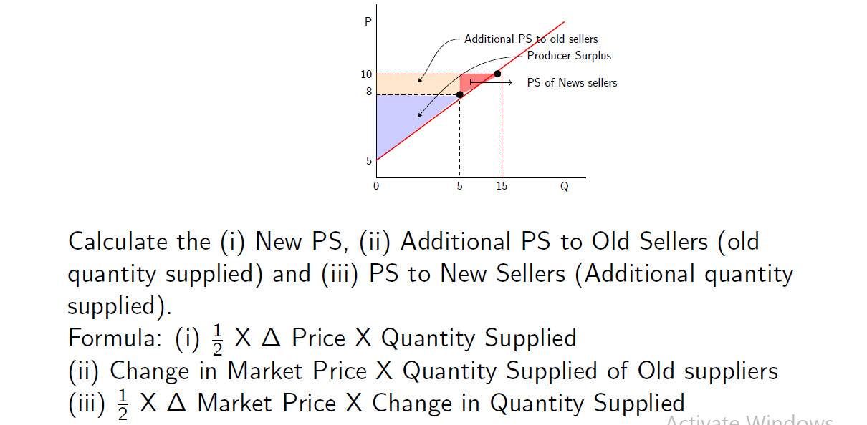

Total Surplus

* Total Surplus is the sum of consumer surplus and producer surplus
* Total surplus measures the total economic welfare

Total Surplus = Consumer Surplus + Producer Surplus

= Willingness to pay - Market Price + Market Price – Economic Cost

= Willingness to Pay - Economic Cost

Total surplus is maximized at the market equilibrium price.

Remember the example of soft drink? You would not pay more than 20tk, you bought a bottle at 15tk. Your seller would not sell a bottle less than 12tk, but sold the product at 15tk. What would be the Consumer surplus? Producer Surplus? Total Surplus?

Market Equilibrium

At market equilibrium price, efficiency in allocation of resources is ensured

Graphical Representation

